Initial Project Planning Template
Date | 29 September 2026
Team ID | 6ab2aa7b1266c775575a9cb4
Project Name | Farm Management System
Maximum Marks | 5 Marks

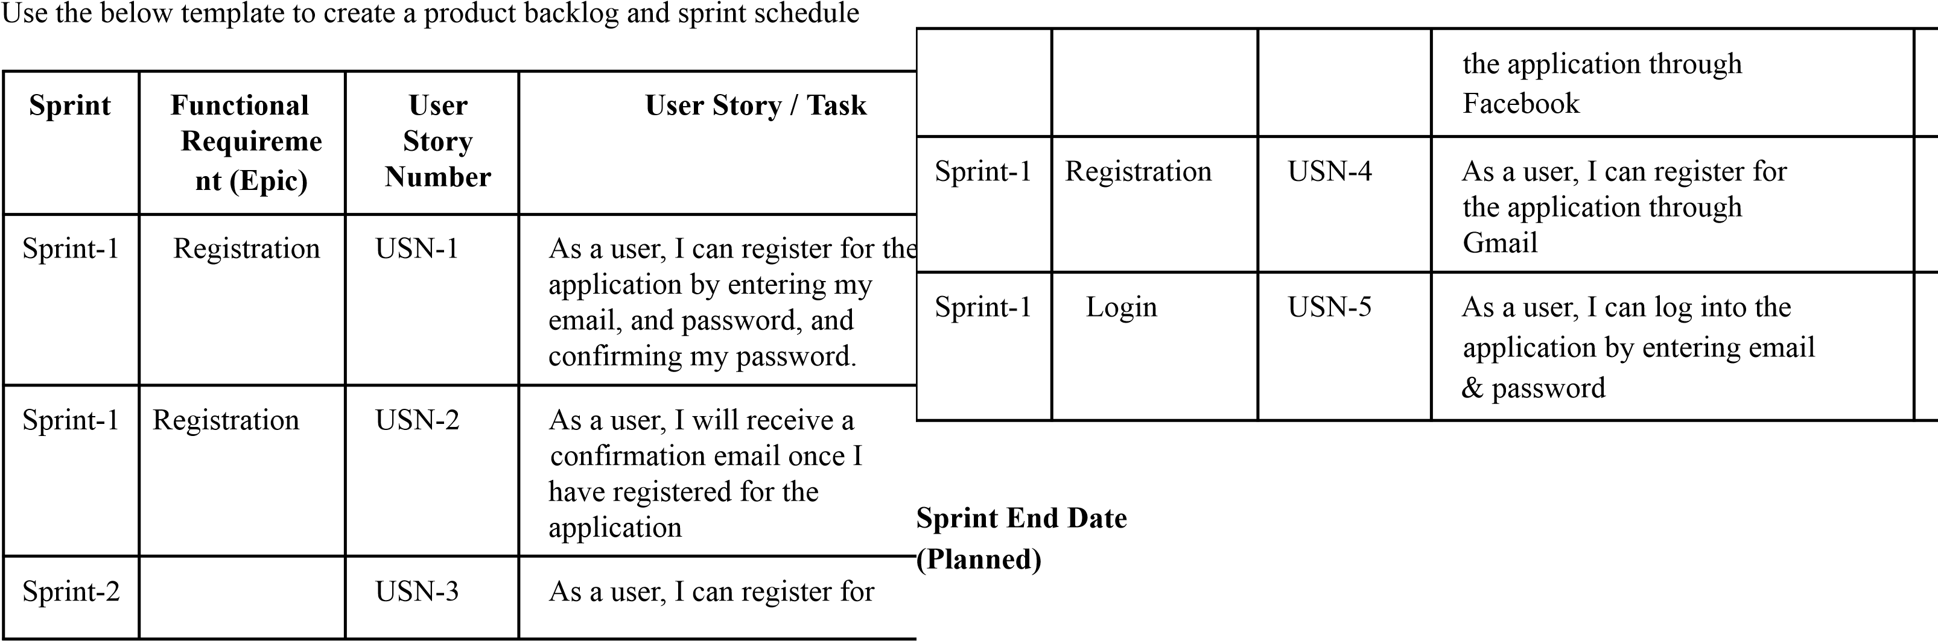
Product Backlog, Sprint Schedule, and Estimation (4 Marks)

